**PROJECT MANAGEMENT PLAN**

***<Travel Anywhere>***

***Group <Group 5>***

***<The Hardys>***

张博文20372211

金海熠20372215

卢景瑜20372216

马骁 20372212

曾天煜20372214

邓瑞天20372229



**Planning Phase**

**Content**

1. Executive Summary 6

1.1. Establish Motivation 6

1.2. Problem Demonstration and System Design 7

1.3. Feasibility Assessment and Implementation Plan 7

1.4. Quantitative and Measurable Objectives 9

1.4.1. Functional requirements 9

1.4.2. Non-Functional Requirements 9

2. Integration Management 10

2.1. Project Team Structure 10

2.2. Roles and Responsibilities 11

2.3. Change Management 12

2.3.1. Change Control 12

2.3.2. Change approval process 14

2.4. Project close out 14

2.4.1. Staff Management 14

2.4.2. Documentation 14

2.4.3. Final Report 15

3. Scope Management 15

3.1. Scope Statement 15

3.2. Requirement Management 16

3.2.1. Functional requirements 16

3.2.2. Non-functional Requirement 17

3.3. Project Deliverable 18

3.4. Work Activities 19

3.5. Constraint 20

3.6. Assumption 20

3.7. Stakeholder 20

4. Time Management 21

4.1. Milestone 24

4.2. Gantte Chart 24

5. Cost Management 26

5.1. Cost Estimation 26

5.1.1. UFC(Unadjusted Function Point Count) 26

5.1.2. TFC(technical complexity factor) 27

5.1.3. FP (Function Point) 28

5.2. Budget Allocation 28

5.3. Budget Control 29

6. Quality Management 30

6.1. Quality objectives and Metrix 31

6.2. Perform quality assurance 32

6.3. Quality Control 32

7. Human Resource Management 33

7.1. Human resources development 35

7.1.1. Training 35

7.2. Regulations 35

7.3. In-practice training 36

7.4. Decision making 36

7.5. Responsibility 37

7.6. Conflict handling 37

8. Communication Management 37

8.1. Stakeholder Analysis 37

8.2. Project Reporting and Communication 39

9. Risk Management 40

9.1. Risk identification 40

9.2. Risk Evaluation 40

9.3. Risk Avoidance 42

9.4. Transfer Risk 42

9.5. Risk Control 43

Revision History

| Version Number | Description | Date Modified | Author |
| --- | --- | --- | --- |
| 1.0 | Preliminary completion of project plan writing. | 2023.6.1 | All group members |
| 1.1 | Some minor changes | 2023.6.3 | All group members |
| 2.0 | Modify baselines and high light them | 2023.6.5 | All group members |
| 3.0 | Final version | 2023.6.8 | All group members |
|  |  |  |  |
|  |  |  |  |

**Authority Signatures**

The Project Lead (Business Side) and the Project Manager agree to deliver the Delivery Stage of this project in accordance with this Project Management Plan and amend it periodically as project parameters change.

|  |  |  |  |
| --- | --- | --- | --- |
| Prepared by: Zhang Bowen,Jin haiyi, Deng ruitian, Lu jingyu, Zeng Tianyu, Ma Xiao | | | |
|  | Signature | | |
| Please print: | |  |  |
|  | Name | ID | Date |

|  |  |  |  |
| --- | --- | --- | --- |
| Approved by: | | | |
|  | | Signature | |
| Please print: |  |  |  |
|  | Name | Title | Date |

# Executive Summary

## Establish Motivation

As a consequence of the severe pandemic, the travel industry has been negatively impacted in recent years. Our client, a family-owned travel agency, was forced to close their offline stores and is now seeking alternative sales channel. According to many researches, the epidemic has had a devastating impact on small offline physical stores while bringing great benefit to the online shops. Therefore, our team decided to transform our client’s physical store into online store.

To address challenges, our project seeks to provide complete travel planning services for a family-based travel agency. First of all, easy-to-follow web pages should available for both customers and travel agents in order to provide a user-friendly experience. For instance, providing multilingual user interface and easy-to-understand guidance. Secondly, functionalities such as view all the destinations, attractions, accommodations, add them to reservation, and edit travel plan should be fully implemented to meet the need of a travel agency. What’s more, the 3D VR preview for accommodation is available for customer to better make decision for choosing accommodation. In addition, when providing reviews from other customers, we use NLP to implement the sentimental analysis and classify them, so that customer could get easier access to positive and negative reviews. Last but not least, qualified communication means should also be ensured in case that customer may encounter any confusion while browsing our web page.

This project is separated into client portal and staff portal. Customers can use the online service of our travel agency through the client portal, while the staff is mainly responsible for managing the data in the system. In addition, staffs can also be contacted with customers through communication platform and Email service. Besides, based on the SOLID principle, the entire project is high cohesion and low coupling in order to reduce the cost for maintaining and upgrading in the future. Last but not least, the database security is addressed by using database encryption and firewalls, and only the staff and maintain team have the access to the data in the system.

## Problem Demonstration and System Design

We extract the problem statement of the requirements, collect the ideas of the stakeholders, and conclude that we need to solve the following problem:

* As a customer
  + Accessibility:
    - Access the cloud-based web page freely through mobile devices or laptops.
    - Access the multilingual interface.
  + Account:
    - Login and register as a customer.
    - Edit the profile. For instance, email address, password or username.
  + Travel services:
    - View all the destinations, attractions, accommodations and their details.
    - Search all the destinations, attractions, accommodations.
    - Search travel package.
    - Make and view comments or reviews on attractions, accommodations.
    - Recommended attractions and accommodation based on other tourist ratings
    - Create reservations and make payments.
    - Cancel a reservation by using customer portal.
    - View and edit the reservation.
    - Trace the status of reservation
  + Communication with staff:
    - Communication with manual customer service.
    - informing issues to staff through Email service.
* As a staff
  + Staff services
    - Manage the information of destination, attraction, accommodation, traffic tickets or travel packages. For instance, the name, introduction, preview pictures or 3D models.
    - Add new destination, attraction, accommodation, traffic tickets or travel packages.
    - Manage the reviews and comments of attraction and accommodation.
    - Manage and track the reservations for customers.
    - Manage the customer accounts.
    - Communication with customers through manual customer service.

## Feasibility Assessment and Implementation Plan

|  |  |  |  |
| --- | --- | --- | --- |
| ID | Requirement description | Technique use | Work load |
| 1 | Access the web pages at any time | Nginx and Docker | 2 weeks |
| 2 | Access through mobile devices and laptops | Bootstrap framework | 3 weeks |
| 3 | Multilingual interface | Bootstrap and Thymleaf | 2 weeks |
| 4 | Login and register | Spring JPA and Spring MVC | 1 week |
| 5 | Manage customer profile | Spring JPA and Spring MVC | 1 week |
| 6 | Create new destination, attraction accommodation, and travel packages | Spring JPA and Spring MVC | 1 week |
| 7 | Manage the existing accommodation, destination, attraction and packages | Spring JPA, Thymleaf and jQuery | 2 weeks |
| 8 | Filter destination, accommodation, attraction and packages | Spring JPA, Thymleaf, jQuery and BM25 model | 3 weeks |
| 9 | Create and view 3D VR models for accommodation | Three.js, jQuery and Bootstrap | 3 weeks |
| 10 | Make reservation | Spring JPA, MVC, jQuery and Thymleaf | 1 week |
| 11 | Manage and track reservation | Spring JPA, jQuery and Thymleaf | 2 weeks |
| 12 | Leave comments and reviews | Spring JPA and Spring MVC | 1 week |
| 13 | Sentimental analysis for reviews | Natural Language Processing model and Spring MVC | 3 weeks |
| 14 | Communication between customers and staff | Web socket, Bootstrap and jQuery | 3 weeks |

## Quantitative and Measurable Objectives

### Functional requirements

* User Registration and Login: Users should be able to register and create accounts on the website. Security verification via email.
* Travel Package Selection: Customers should have the ability to browse and select different travel packages offered by the agency. They should be able to view package details, including destinations, itineraries, pricing, and comments.
* Destination Search and Information: Users should be able to search for specific destinations and access detailed information about each location, including attractions, accommodations, local customs, and travel tips.
* Planning Tools: The website should provide planning tools such as itinerary builders, budget calculators, and weather information to assist users in organizing their trips effectively.
* Online Booking and Payment: Customers should be able to book their preferred travel packages online and make secure payments through various payment options.
* Communication Platform: The website should include a messaging or chat feature that enables direct communication between customers and agency staff. This feature should facilitate quick responses to customer inquiries and provide personalized assistance.

### Non-Functional Requirements

* Portability: The website should be compatible with multiple web browsers and operating systems, ensuring accessibility across different platforms. Users should be able to access and use the website seamlessly regardless of their preferred browser or operating system.
* Security: The website should implement robust security measures, including encryption protocols and secure authentication, to protect user data and prevent unauthorized access.Adequate measures should be in place to detect and prevent common security threats, such as SQL injection and cross-site scripting, ensuring the website's security.
* Maintainability: The website's code and architecture should be well-structured and documented, facilitating easy maintenance and updates. Adherence to coding best practices and modular design should be emphasized to enhance code maintainability and support future enhancements.
* Reliability: The website should demonstrate a high level of reliability, with minimal downtime and system failures, ensuring uninterrupted access for users. Regular system monitoring and proactive error handling mechanisms should be implemented to identify and resolve issues promptly.
* Scalability: The website should be designed to handle increased user traffic and data volume, enabling seamless scalability as the user base grows. Both hardware and software components should be scalable to accommodate increased demand without compromising performance.
* Performance: The website should provide fast response times and quick loading of pages, delivering a smooth user experience with minimal waiting times. Performance testing should be conducted to optimize website performance and identify areas for improvement to ensure optimal speed and efficiency.
* Reusability: The website's code should be modular and reusable, promoting efficient development and maintenance of new features or modules. Common functionalities and components should be designed to be reusable across different sections of the website, minimizing duplication and maximizing code efficiency.
* Flexibility: The website should be flexible enough to adapt to changing business requirements, allowing for easy customization and integration of new functionalities or third-party services. Administrators should have access to configuration options and settings to tailor the website's behavior and appearance according to specific needs.

# Integration Management

This section mainly introduces comprehensive integration management which involved identifying, defining, combining, unifying and coordinating the process in a project. cture

## Project Team Structure

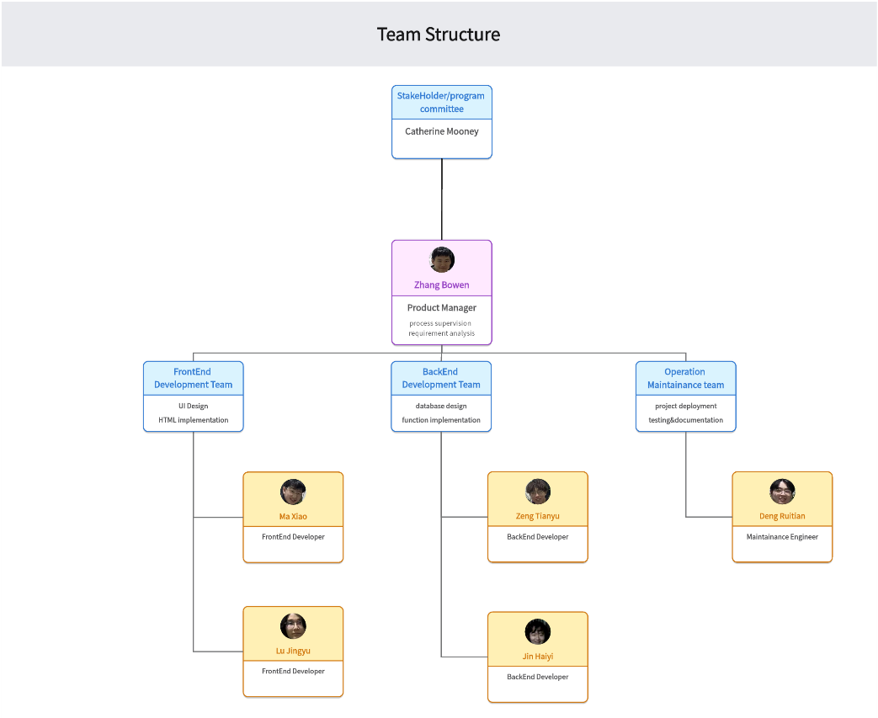

## Roles and Responsibilities

|  |  |  |
| --- | --- | --- |
| Project Position | Name | Responsibilities |
| Stakeholder/Program Committee | Catherine Mooney | Oversee and evaluate the project |
| Project Manager | Zhang Bowen | Supervise the development process and consult requirements with program committee and development teams |
| FrontEnd Developer | Ma Xiao, Lu Jingyu | Responsible for the UI design and implementation of the frontend page |
| BackEnd Developer | Jin Haiyi, Zeng Tianyu | Mainly in charge of the establishment of the database and the implementation of the backend function |
| Maintainance developer | Deng Ruitian | Involved in the deployment and testing of the project while in charge of documentation |

## Change Management

### Change Control

This section introduces the whole process of handling changes in this project. All changes should follow the process mentioned in the diagram.

Once the change is proposed, it should draft the scope and requirements, analyzing its accessibility and its impact on the overall project. The decision would be made by being approved or rejected by the stakeholder after conferring with the development team, proposal may then need to revise and repeat the above steps.

After the acceptance of the proposal, changes would be notified to the following development team and then be implemented. Configuration management may be involved. After the implementation, the result would be verified by the project manager and then be delivered to the stakeholder. Documents would consistently be updated during the whole process.

The one who requests changes should be responsible for concluding all the aspects that changes may involve in the project, for example, the scope changes, and feasibility analysis, and risk evaluation, and so on.

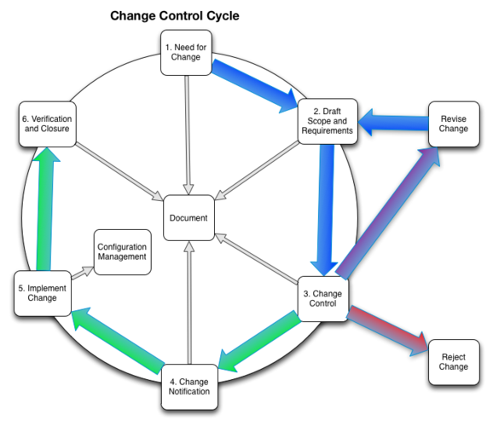Taking several factors into consideration, Evaluating the cost of several changes in terms of work complexity, time cost, and the magnitude of the proposal.

|  |  |  |  |  |
| --- | --- | --- | --- | --- |
| Perspective | Changing degree | | | |
| A | B | C | D |
| Budget changes | No extra budget required | An extra 5% of the original budget required | An extra 10% of the original budget required | An extra 20% of the original budget required |
| Scope changes | Require the least changes to the techniques | A change to a single model or a change to a specific technology | A change to some technologies and functions | A change to the overall software architecture |
| Personnel changes | No personnel changes | A change requires a single development sub-team involved in | A change requires few development sub-team involves in | A change requires the whole team involves in |
| Outcome changes | The outcome is visible and satisfying with a detailed description | The outcome is somehow clear with an ambiguous description | The outcome is vague | No clear blueprint for the outcome |

### Change approval process

When the proposal is accepted and approved by the stakeholders, the request would goes directly to the next stage. The change request would eventually be terminated when after successfully implemented.

When a change proposal is declined or rejected by the stakeholder or the project manager, the request would go directly to the closure of the current process.

If the proposal receives a revised suggestion, the proposal could be re-proposed after being revised.

## Project close out

Once the project is finished, different models should have their following arrangement.

### Staff Management

Every team member would be evaluated on the basis of their participation and contribution to the project. The assessment result would have an impact on the work division of the other project. A developer who receives a high reputation would be responsible for the same section in the following project.

In addition, a developer who is in charge of the operation and maintenance is required to maintain and follow up the project.

### Documentation

Documentations generated during the project should be evaluated respectively in terms of different sections, for example, the risk analysis, the development schedule and so on. It would an important reference for the following project development.

### Final Report

The final report is the review of the whole project. The report should summarize the effective decisions made during the project while including the outcomes (for example, the specific cost and time allocation eg.)

If the project has met certain difficulties and terminated fortuitously, causes of the termination should be analyzed and recorded in the final report, specifying the problem and then deliver to the stakeholder.

# Scope Management

At the project's inception, it is essential to determine what aspects will be included and excluded. Scope management, scope change control, and scope verification are integral to managing the project's scope. Other components of scope management include defining project requirements and planning the project's scope. The goal of scope management is to ensure a shared understanding among all project team members and stakeholders regarding the products generated by the project and the processes used to develop them.

During the project's delivery stage, scope management plays a critical role. We manage the scope through scope verification and control, work breakdown structure (WBS), roles and responsibilities, tools and techniques, and reporting. Scope verification ensures compliance of deliverables with the requirements, while scope control monitors changes. The WBS helps the team manage work packages, and roles and responsibilities clarify duties. Tools and techniques support scope management, while reporting facilitates timely communication of scope status. Effective scope management ensures successful project delivery.

## Scope Statement

|  |  |
| --- | --- |
| Activities In Scope | Activities Out of Scope |
| Requirement gathering and analysis | External partnerships unrelated to project |
| Product design and development | Hardware or software procurement |
| Define scope | financial management beyond project controls |
| Project management and coordination | Activities specific to other concurrent project |
| Documentation for end-users | Organizational restructuring |
| Stakeholder communication and engagement |  |
| Risk management |  |
| Resource allocation |  |
| Ongoing maintenance and support |  |

## Requirement Management

Requirements management is essential for project success as it ensures clear communication and alignment of project requirements. It involves identifying, documenting, and controlling requirements throughout the project lifecycle. By following a structured approach, the project team can gather, analyze, and validate requirements effectively, minimizing scope creep and misunderstandings. This section outlines key activities such as requirements elicitation, documentation, traceability, change control, and verification. Engaging stakeholders, fostering collaboration, and maintaining effective communication are crucial for well-defined and achievable requirements. With robust requirements management, the project can meet customer expectations, deliver desired outcomes, and achieve success.

### Functional requirements

* User Registration and Login: Users should be able to register and create accounts on the website. Security verification via email.
* Travel Package Selection: Customers should have the ability to browse and select different travel packages offered by the agency. They should be able to view package details, including destinations, itineraries, pricing, and comments.
* Destination Search and Information: Users should be able to search for specific destinations and access detailed information about each location, including attractions, accommodations, local customs, and travel tips.
* Planning Tools: The website should provide planning tools such as itinerary builders, budget calculators, and weather information to assist users in organizing their trips effectively.
* Online Booking and Payment: Customers should be able to book their preferred travel packages online and make secure payments through various payment options.
* Communication Platform: The website should include a messaging or chat feature that enables direct communication between customers and agency staff. This feature should facilitate quick responses to customer inquiries and provide personalized assistance.

### Non-functional Requirement

* Portability: The website should be compatible with multiple web browsers and operating systems, ensuring accessibility across different platforms. Users should be able to access and use the website seamlessly regardless of their preferred browser or operating system.
* Security: The website should implement robust security measures, including encryption protocols and secure authentication, to protect user data and prevent unauthorized access.Adequate measures should be in place to detect and prevent common security threats, such as SQL injection and cross-site scripting, ensuring the website's security.
* Maintainability: The website's code and architecture should be well-structured and documented, facilitating easy maintenance and updates. Adherence to coding best practices and modular design should be emphasized to enhance code maintainability and support future enhancements.
* Reliability: The website should demonstrate a high level of reliability, with minimal downtime and system failures, ensuring uninterrupted access for users. Regular system monitoring and proactive error handling mechanisms should be implemented to identify and resolve issues promptly.
* Scalability: The website should be designed to handle increased user traffic and data volume, enabling seamless scalability as the user base grows. Both hardware and software components should be scalable to accommodate increased demand without compromising performance.
* Performance: The website should provide fast response times and quick loading of pages, delivering a smooth user experience with minimal waiting times. Performance testing should be conducted to optimize website performance and identify areas for improvement to ensure optimal speed and efficiency.
* Reusability: The website's code should be modular and reusable, promoting efficient development and maintenance of new features or modules. Common functionalities and components should be designed to be reusable across different sections of the website, minimizing duplication and maximizing code efficiency.
* Flexibility: The website should be flexible enough to adapt to changing business requirements, allowing for easy customization and integration of new functionalities or third-party services. Administrators should have access to configuration options and settings to tailor the website's behavior and appearance according to specific needs.

## Project Deliverable

|  |  |  |  |
| --- | --- | --- | --- |
| Deliverable | Recipients | Delivery Date | Delivery Method |
| Project agreement | All develop teams, PM | 2022/02/28 | UCD-CSMoodle |
| Gantt and work package | All develop teams, PM | 2022/03/07 | UCD-CSMoodle |
| Project charter | All develop teams, PM | 2022/03/14 | UCD-CSMoodle |
| Project management plan | All develop teams, PM | 2022/03/14 | Github |
| Back-end design | Back end development team, PM | 2022/03/31 | Github |
| Database design | Back end development team, PM | 2022/03/31 | Github |
| Front-end design | Front end development team, PM | 2022/04/07 | Github |
| User and Staff system | All develop teams, PM | 2022/04/14 | Github |
| Booking system | All develop teams, PM | 2022/04/28 | Github |
| Draft user and system  documentation | All develop teams, PM | 2022/05/07 | UCD-CSMoodle |
| Functional video | All develop teams, PM | 2022/05/24 | UCD-CSMoodle |
| Final user and system  documentation | All develop teams, PM | 2022/06/02 | UCD-CSMoodle |
| Presentation and final code | All develop teems, PM | 2022/06/02 | UCD-CSMoodle |

## Work Activities

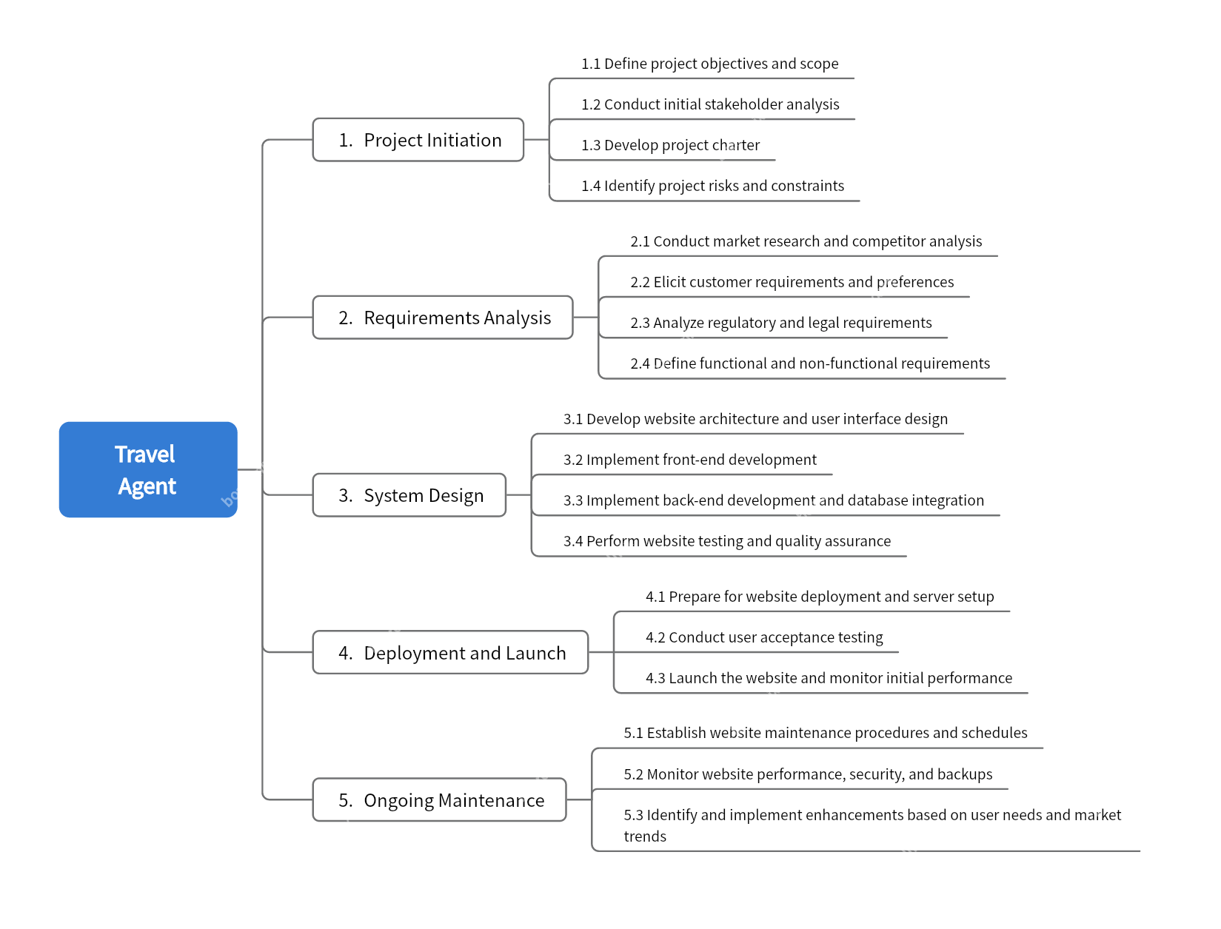

## Constraint

* A mid-sized project needs to be completed by June 2nd, with less than three months to go.
* The administrator account already exists when the project is released. It cannot be registered by any customer or staff.
* All private information stored in the database, such as passwords, needs to be encrypted.

## Assumption

* Data security measures will be implemented.
* The website will be compatible with modern web browsers.
* The website will be developed using responsive design principles.
* All team members were involved in the development process.
* The project is deployed to the UCD server and all users can connect remotely.

## Stakeholder

|  |  |
| --- | --- |
| Client | Travel website customers and staffs |
| Sponsor | Dr. Catherine Mooney |
| Project manager | Zhang Bowen |
| Project team members | Jin Haiyi, Deng Ruitian, Ma Xiao, Lu Jingyu, Zeng Tianyu |

# Time Management

The importance of time management in project planning cannot be underestimated. A successful project plan requires the proper allocation of time to ensure that the project is completed on time and achieves its objectives. It helps the team in effectively planning and allocating time, resources, and task priorities, reducing risks, ensuring timely project completion, and providing opportunities for feedback and improvement. Effective time management is an integral part of project success.

The time management for this project consists of seven time management processes: plan schedule management, define activities, sequence activities, estimate activity resources, estimate activity duration, develop schedule, and control schedule. The objective of time management in this plan is to maximize the utilization of available time resources, ensure control over the project schedule, and achieve the objectives within the specified timeframe.

After conducting time planning, it is important to regularly monitor the progress of the project, compare it with the time schedule, and identify any deviations or delays. Based on the actual progress, the time schedule should be adjusted, tasks and resources rearranged to ensure that the project stays on track for timely completion.

First, there is the "plan schedule management" process for this project. The inputs for this process are the project management plan, project charter, and team environmental factors. The tools and techniques used include analytical techniques and meetings. The output of this process is the schedule management plan.

The schedule management plan specifies the project schedule model, the frequency and length of schedule updates, accuracy, units of measure, threshold values for variances, performance measurement rules, priorities, and more. It provides guidelines for developing and controlling the project schedule.

Next, the "define activities" process is carried out, followed by creating the project schedule network diagram through the "sequence activities" process.

|  |  |
| --- | --- |
| A: Define project objectives | O:Develop website architecture and user interface design |
| B: Define project scope | P: Implement front-end development |
| C: Conduct initial stakeholder analysis | Q:Implement back-end development and database integration |
| D: Develop project charter | R:Perform website testing and quality assurance |
| E: ldentify project risks | S:Prepare for website deployment and server setup |
| F: ldentify project constraints | T: Conduct user acceptance testing |
| G: Conduct market research | U: Launch the website and monitor initial performance |
| H: Conduct market competitor analysis | V: Establish website maintenance procedures and schedules |
| I: Elicit customer requirements | W:Monitor website performance, security, and backups |
| J: Elicit customer preferences | X: ldentify and implement enhancements based on user needs and markettrends |
| K: Analyze regulatory requirements |  |
| M: Define functional requirements |  |
| N: Define non-functional requirements |  |

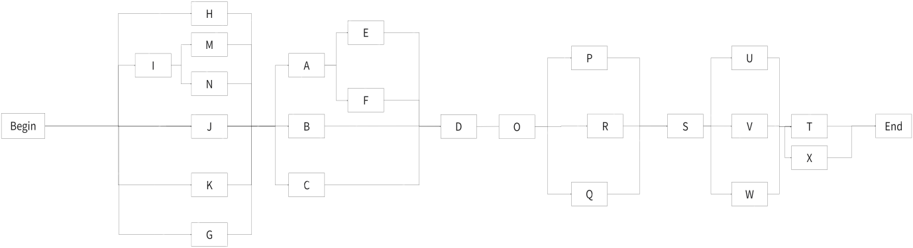

After completing the Project schedule network diagram, we need to estimate the duration of each activity. In this plan,the method of three-point estimating was used for estimation, and the assumed distribution was chosen as beta distribution.

|  |  |  |  |  |
| --- | --- | --- | --- | --- |
| Activity | tM | tO | tP | tE |
| A | 4 | 3 | 5 | 4.0 |
| B | 3 | 1 | 4 | 2.8 |
| C | 5 | 2 | 7 | 4.8 |
| D | 5 | 3 | 7 | 5.0 |
| E | 3 | 2 | 6 | 3.3 |
| F | 4 | 2 | 5 | 3.8 |
| G | 3 | 2 | 6 | 3.3 |
| H | 3 | 2 | 5 | 3.1 |
| I | 2 | 1 | 4 | 2.1 |
| J | 2 | 1 | 4 | 2.1 |
| K | 3 | 2 | 5 | 3.1 |
| M | 3 | 2 | 4 | 3.0 |
| N | 4 | 2 | 5 | 3.8 |
| O | 7 | 3 | 9 | 6.6 |
| P | 7 | 4 | 9 | 6.8 |
| Q | 7 | 5 | 8 | 6.8 |
| R | 10 | 8 | 12 | 10.0 |
| S | 6 | 3 | 8 | 5.8 |
| T | 7 | 5 | 9 | 7.0 |
| U | 5 | 3 | 6 | 4.8 |
| V | 8 | 5 | 11 | 8.0 |
| W | 10 | 7 | 12 | 9.8 |
| X | 10 | 7 | 17 | 10.7 |

## Milestone

|  |  |
| --- | --- |
| Description | Forecast Date |
| Define project objectives and scope | 2023/03/01 |
| Conduct initial stakeholder analysis | 2023/03/09 |
| Develop project charter | 2023/03/14 |
| Reserve | 2023/03/21 |
| Conduct market research and competitor analysis | 2023/03/28 |
| Elicit customer requirements and preferences | 2023/04/04 |
| Analyze regulatory and legal requirements | 2023/04/07 |
| Define functional and non-functional requirements | 2023/04/10 |
| Develop website architecture and user interface design | 2023/04/17 |
| Implement back-end development and database integration | 2023/04/24 |
| Implement front-end development | 2023/05/16 |
| Perform website testing and quality assurance | 2023/06/04 |

## 下载 (1)Gantte Chart

Finally, we use Critical Path Method to calculate the critical paths and the amount of total and free float or scheduling flexibility on the logical network paths within the schedule model.

|  |  |  |  |  |  |  |
| --- | --- | --- | --- | --- | --- | --- |
| Activity | ES | EF | LS | LF | Duration | Float |
| A | 6 | 9 | 9 | 12 | 4 | 0 |
| B | 6 | 8 | 13 | 15 | 3 | 5 |
| C | 6 | 10 | 11 | 15 | 5 | 3 |
| D | 13 | 17 | 16 | 20 | 5 | 0 |
| E | 10 | 12 | 13 | 15 | 3 | 1 |
| F | 10 | 13 | 12 | 15 | 4 | 0 |
| G | 1 | 3 | 10 | 12 | 3 | 2 |
| H | 1 | 3 | 10 | 12 | 3 | 2 |
| I | 1 | 2 | 9 | 10 | 2 | 0 |
| J | 1 | 3 | 11 | 12 | 2 | 3 |
| K | 1 | 2 | 11 | 12 | 2 | 3 |
| M | 3 | 5 | 10 | 12 | 3 | 0 |
| N | 3 | 5 | 10 | 12 | 3 | 0 |
| O | 18 | 23 | 21 | 26 | 6 | 0 |
| P | 24 | 30 | 27 | 33 | 7 | 3 |
| Q | 24 | 30 | 27 | 33 | 7 | 3 |
| R | 24 | 33 | 24 | 33 | 10 | 0 |
| S | 31 | 36 | 34 | 39 | 6 | 0 |
| T | 42 | 48 | 45 | 51 | 7 | 3 |
| U | 37 | 41 | 40 | 44 | 5 | 5 |
| V | 37 | 44 | 37 | 44 | 8 | 2 |
| W | 37 | 46 | 35 | 44 | 10 | 0 |
| X | 42 | 51 | 42 | 51 | 10 | 0 |

# Cost Management

## Cost Estimation

The cost would mainly include the following three aspects, human resources, software access, and the operation maintenance cost.

|  |  |  |  |  |  |
| --- | --- | --- | --- | --- | --- |
| WBS Items | Unit/Hrs. | Cost/Unit/Hr. | Subtotals | WBS level 1 total | % of total |
| Project management |  |  |  | 442,200$ | 24% |
| Project manager | 960 | 120$ | 115,200$ |  |  |
| Project team member | 2180 | 150$ | 327,000$ |  |  |
| Hardware |  |  |  | 60,000$ | 4% |
| Server renting | 5 | 2000$ | 10,000$ |  |  |
| Digital devices | 100 | 500$ | 50,000$ |  |  |
| Software |  |  |  | 340,000$ | 30% |
| Software license access | 100 | 200$ | 20,000$ |  |  |
| Software development |  |  | 320,000$ |  |  |
| Testing  (10% cost of the total hardware and software ) |  |  |  | 400,000$ | 22% |
| Reserves  (20% of total estimation) |  |  |  | 310,928$ | 20% |
| Total cost estimation |  |  |  | 1,865,568$ | 100% |

### UFC(Unadjusted Function Point Count)

|  |  |  |  |
| --- | --- | --- | --- |
| Feature Count items | Complexity weight | | |
| Simple | Medium | Complex |
| External input | 3 | 4 | 6 |
| External output | 4 | 5 | 7 |
| External inquiry | 3 | 4 | 6 |
| External interface file | 5 | 7 | 12 |
| Internal documents | 7 | 10 | 15 |

|  |  |  |
| --- | --- | --- |
| Feature count items | counts | Complexity weight |
| External input | 2 complex, 1 simple | 15 |
| External Output | 3 medium, 2 medium | 22 |
| External inquiry | 2 complex, 1 medium | 16 |
| External interface file | 2 medium, 2 simple | 24 |
| Internal documents | 1 complex, 1 medium, 1 simple | 32 |

### TFC(technical complexity factor)

|  |  |  |  |
| --- | --- | --- | --- |
| Technical complexity factors | | | |
| F1 | Reliable backup and recovery | F2 | data communication |
| F3 | Distributed function | F4 | performance |
| F5 | Large use of configuration | F6 | Online data entry |
| F7 | Simplicity of operation | F8 | Online upgrade |
| F9 | Complex interface | F10 | Complex data processing |
| F11 | Reusability | F12 | Installation simplicity |
| F13 | Multiple Sites | F14 | Easy to modify |

|  |  |  |  |  |  |
| --- | --- | --- | --- | --- | --- |
|  | Technical complexity factors | | | |  |
| F1 | Reliable backup and recovery | 3 | F2 | data communication | 2 |
| F3 | Distributed function | 1 | F4 | performance | 4 |
| F5 | Large use of configuration | 1 | F6 | Online data entry | 2 |
| F7 | Simplicity of operation | 4 | F8 | Online upgrade | 1 |
| F9 | Complex interface | 2 | F10 | Complex data processing | 0 |
| F11 | Reusability | 2 | F12 | Installation simplicity | 2 |
| F13 | Multiple Sites | 1 | F14 | Easy to modify | 4 |

### FP (Function Point)

We estimate that each FP needs 8 hours to complete, so the workload is：

We set the average hourly wage for our employees at 50 yuan per hour. Plus the hardware costs 50,000 yuan , So the total funding of the project is:

We can figure it out:

Most likely(cM):

Optimistic (cO): 75,000

Pessimistic (cP): 105,000

According to Three-point estimation, the beta distribution is 90,656 yuan

## Budget Allocation

|  |  |
| --- | --- |
| Category | Estimate Cost |
| Administrative expenses | 4.6 |
| Personnel wages | 2 |
| Hardware cost | 1 |
| Service charge | 1 |
| Reserve | 0.5 |

## Budget Control

To ensure adherence to the financial utilization plan after its completion, the following steps and measures need to be taken:

Monitor cash flow: Regularly monitor the flow of funds in the project, including inflows and outflows. Compare it with the actual utilization of funds to ensure that the funds are being used according to the plan.

Fund recording and reporting: Establish a detailed fund recording system to document the usage of each fund and generate regular fund reports. This allows for clear tracking of fund movement, timely identification of variances, and implementation of corrective measures.

Internal auditing: Conduct internal audits to review the utilization of project funds. Through independent auditing procedures, verify if fund usage aligns with the plan and ensure compliance and transparency.

Change management: If changes occur in the financial utilization plan, appropriate change management must be carried out. Ensure that changes are evaluated, approved, and effectively implemented in the revised plan.

Risk management: Identify and assess risks associated with fund utilization and implement corresponding risk management measures. This includes preparing contingency plans to address potential risks and making adjustments when necessary to ensure adherence to the plan.

Communication and stakeholder management: Engage in effective communication with the project team and relevant stakeholders to ensure their understanding of the financial utilization plan and its importance. Share information about fund utilization in a timely manner, providing necessary explanations and updates.

Monitoring and control: Establish monitoring and control mechanisms to ensure strict adherence to the financial utilization plan by the project team and stakeholders. Monitor project progress and outcomes to promptly identify and rectify any deviations.

In addition, we can also use Earned Value Management (EVM) to assess whether we should maintain or modify the cost management plan.

Planned Value (PV)

Earned Value (EV)

Actual Cost (AC)

Schedule Variance (SV) = EV – PV

Cost Variance (CV) = EV – AC

Schedule Performance Index (SPI) = EV / PV

Cost Performance Index (CPI) = EV / AC

Estimate at completion(EAC) = AC+(BAC – EV)

If the difference between BAC and EV is negative, it indicates the need for resource reallocation.

# Quality Management

Quality management is a systematic approach and process aimed at ensuring that products, services, or projects meet pre-defined quality standards and customer requirements. It involves planning, controlling, and improving activities and processes at each stage to achieve the goal of consistently delivering high-quality outcomes. Its purpose is to provide a structured and process-driven approach to managing and ensuring the quality of products or services, meeting customer needs and expectations, and achieving customer satisfaction. It also aims to fulfill customer requirements, enhance product quality, improve efficiency and effectiveness, reduce costs, maintain consistency and traceability, drive continuous improvement, and control risks.

## Quality objectives and Metrix

* Objectives

To fulfill customer requirements and quality standards, ensuring the website's functional completeness, usability, and performance reliability. Additionally, providing innovative features that align with the website's positioning and are reliable to deliver a superior user experience.

* Metrics

Usability of the interface: Ensuring the website interface is user-friendly for both customers and staff through user testing and feedback. The interface layout should be adaptable to different device resolutions.

Functional completeness: Completing all required functionalities as per customer demands and ensuring they are error-free through testing.

Website loading time: Optimizing website performance to control page loading time within acceptable limits, considering network and server limitations since the project is deployed on UCD servers.

Accuracy of information: Validating the accuracy of travel destination, attractions, reviews, and accommodation information, as well as the accuracy of scraped popular tourist attraction rankings.

Data security: Storing sensitive information such as passwords and personal data in encrypted form within the database.

Error rate: Controlling the error rate within a certain range through functional and integration testing.

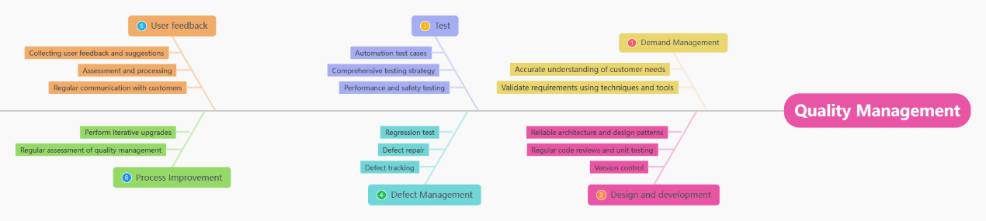

## Perform quality assurance

Executive Quality Assurance (EQA) is a series of activities undertaken during the implementation of a project to ensure that the project follows the quality management plan and relevant standards. The following are the main steps in implementing quality assurance

|  |  |  |  |  |
| --- | --- | --- | --- | --- |
| Project Process | Process Quality Standard | Quality Assurance Activity | Test progress | Person in Charge |
| Defining quality objectives and standards | Identify applicable quality standards and related requirements, including industry standards, regulations and customer requirements | Objectives and standards should be agreed by all members of the development team | Beginning | Project manager |
| Develop quality plan | Develop detailed quality management plans including strategies, methods and activities for quality control, quality assurance and quality improvement | Reviewed by the testers and project managers of the team | Beginning | Project manager |
| Conducting quality reviews and monitoring | Ensure that the project team performs its work in accordance with the quality plan and relevant standards and that any quality deviations are corrected in a timely manner | The testers and project manager of the team are required to review and monitor according to the plan | Weekly | Project manager and testers |

## Quality Control

Quality control aims to monitor the quality of project deliverables, results or deliverables and ensure that they meet pre-defined quality standards and requirements. Controlling quality ensures that the quality of project deliverables meets expectations by performing quality measurement, quality review and verification activities, and by identifying and correcting quality deviations.

|  |  |  |  |
| --- | --- | --- | --- |
| Test Range | Quality Standard | Quality Assurance Activity | Test progress |
| System functionality testing | Verify that the system functions properly as described in the requirements specification, including the public customer portal and the employee portal | Using black box testing methods, write test cases based on the requirements specification and execute the tests to verify the functionality of the system | Every milestone |
| Interface testing | Validate the consistency, ease of use and responsiveness of the user interface to ensure that users can easily use the site to make reservations, access information and communicate with the company | Human-computer interaction testing to verify consistency and ease of use of the user interface | Weekly |
| Compatibility testing | Test the compatibility of the system on different browsers and mobile devices to ensure that it works well on all platforms | Tested on various browsers and mobile devices to ensure system compatibility across platforms | Deployment phase |
| Safety testing | Testing of system security, including authentication, access control and data protection | Conduct security vulnerability scans, identity verification tests and data protection tests to ensure system security. | Each milestone |
| Performance testing | Ensure that system load times are kept within acceptable limits and that a high number of concurrent users is acceptable | Use load testing tools to simulate user access under different load conditions and monitor system performance metrics | Integration testing phase |

# Human Resource Management

In this project, human resource management involves planning, organizing, directing, and controlling the human resources of the project team to ensure effective utilization and management of team members' abilities, skills, and experiences. Human resource management aims to meet the project's human resource requirements to achieve project objectives and provide support and motivation to team members for high performance and project success.

Personnel Composition and Responsibilities:

Project Manager: Bowen Zhang

Backend Developers: Tianyu Zeng, Haiyi Jin

Frontend Developer: Xiao Ma, Jingyu Lu

Deployment and Testing Personnel: Ruitian Deng

In our team, Bowen Zhang is also responsible for backend development. Haiyi Jin also serves as the employee manager. Xiao Ma also serves as a UI designer. Jingyu Lu is responsible for quality supervision.

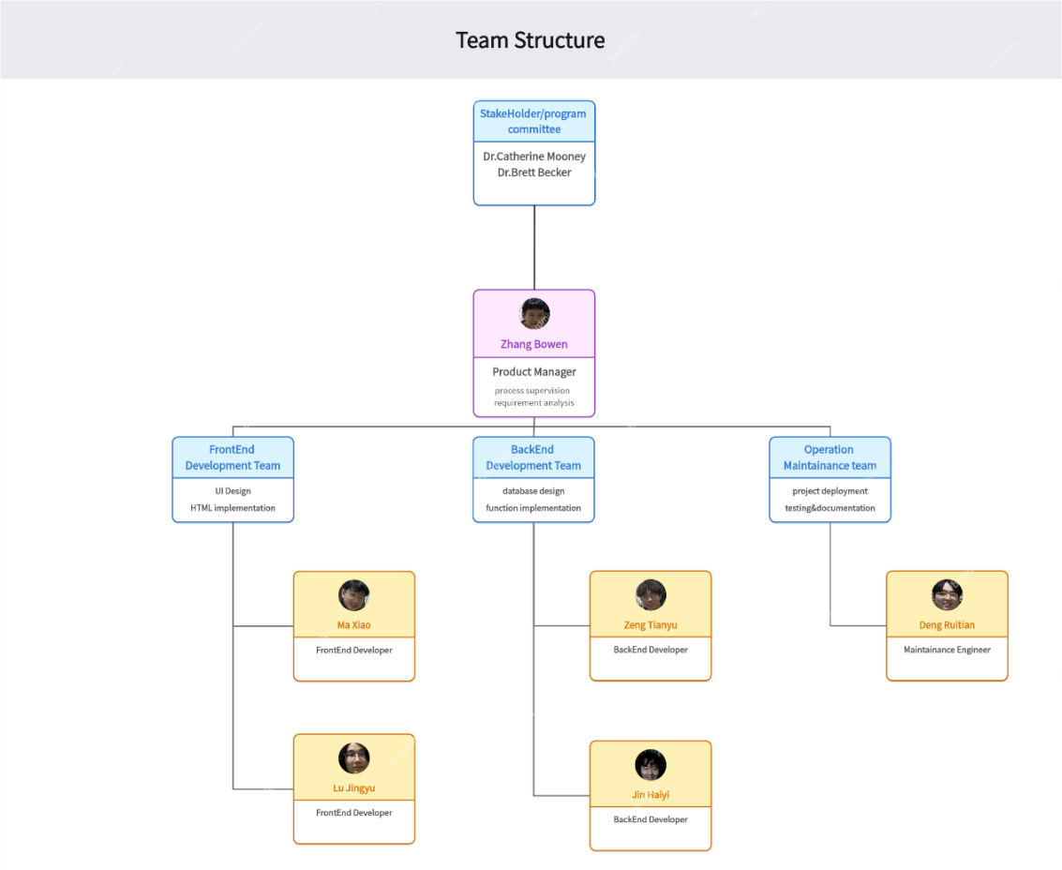

|  |  |  |  |  |  |  |
| --- | --- | --- | --- | --- | --- | --- |
| RACI Chart | Team members | | | | | |
| Activity | Bowen Zhang | Haiyi Jin | Tianyu Zeng | Xiao Ma | Jingyu Lu | Ruitian Deng |
| Collect Requirements | A | R | R | C | C | I |
| Create Charter | R | C | A | I | R | R |
| Create Plan | C | A | R | R | I | R |
| Develop Project | A | R | R | R | C | I |
| Submit Change Request | I | R | I | R | A | C |
| Test Functions | R | I | C | R | C | A |
| Write Documents | I | C | R | C | A | R |

## Human resources development

### Training

Before starting the project, team members must learn how to utilize two technologies that will be used in collaboration: Overleaf and GitLab. Overleaf is used for writing all project-related documents, while GitLab is used for version control and agile development.

Team members should be proficient in using the required technology stack for the project:

Framework: Spring Boot

Frontend: HTML5

Database: MySQL

Team members must also understand how to communicate effectively with each other and adhere to the schedule set during weekly meetings.

## Regulations

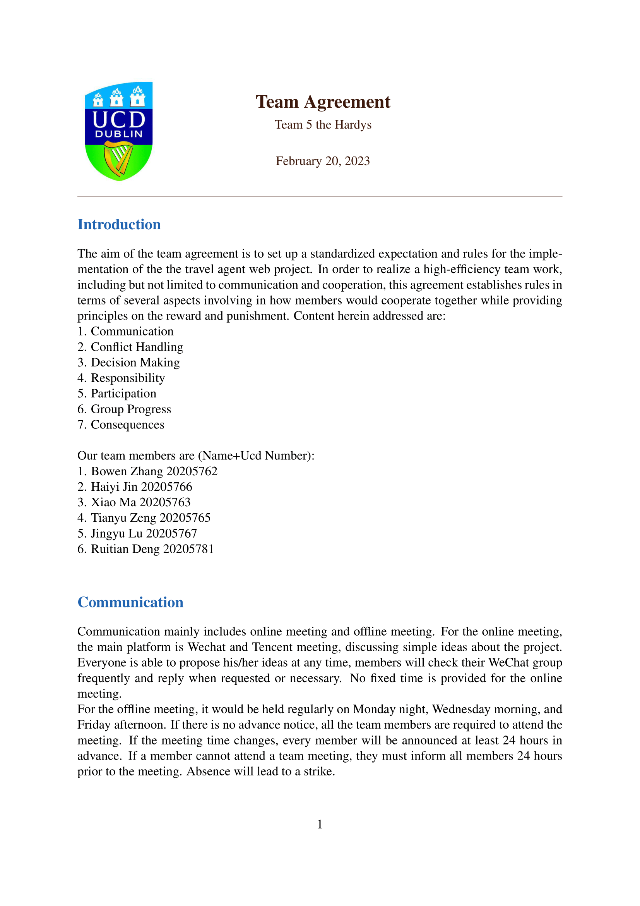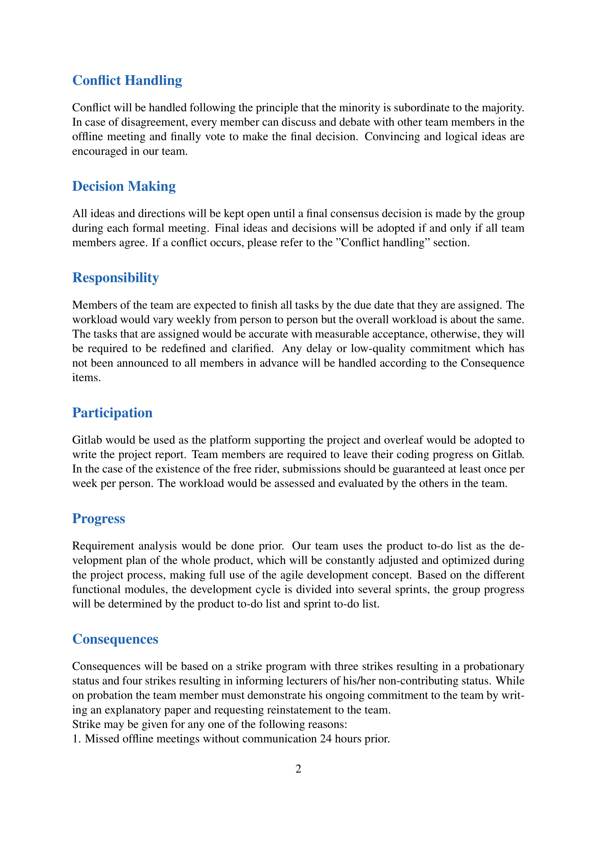

## In-practice training

During the development of the project, all members should be constantly learning the new technologies needed to meet the development needs, and all decisions should be made democratically

## Decision making

In order to develop our group projects correctly and to increase the efficiency of our cooperation, while avoiding conflicts and discordant voices. Our groups are flat and leaderless, every member is expected to participate in the discussion of each resolution and we decide democratically which resolution to implement, based on each member's suggestions. If a team member has a problem that he or she is having difficulty dealing with on his or her own, he or she can bring it up at the weekly meeting, where a decision will be made whether to add staff to the team or change tasks. Although each person in the team is responsible for the development of a different module, other members should also pay attention and focus on other parts of the development task in order to solve problems encountered in development in the first place. In the end, we are able to better realise the client's requirements and innovate on the basis of this by taking on board brilliant and useful suggestions.

## Responsibility

The tasks of the group work will be distributed according to the part in which each person is specialised. Each team member is responsible for their own specific task, such as front-end or back-end development. Members must complete the tasks assigned to them on time. The complexity of the project means that there will be technical overlaps between the different functions in the development process and also that there will be difficult obstacles to overcome. This is where each member of the team needs to bring their strengths to bear, pooling their ideas and providing constructive input in their area of expertise. Our team's aim is to assign each member to the task that best matches their abilities, in order to maximise each person's strengths and achieve agile development.

## Conflict handling

On some resolutions we will inevitably hold opposing views, and active discussion promotes innovation and diversity in our group; in all discussions, the one-word resolution format is not allowed. At the same time, any actions that could escalate positive discussions into violent confrontations are absolutely forbidden, as they can seriously hinder the progress of the whole group and weaken the cohesion of unity. In the event of a sudden violent confrontation, we will resolve it in the manner set out in the rules and regulations, which include resolution rulings and forms of punishment. Team members are expected to do their utmost to maintain a peaceful, fair and pleasant cooperation.

# Communication Management

## Stakeholder Analysis

|  |  |  |  |
| --- | --- | --- | --- |
| **Stakeholder Name** | **How they will impact the project** | **How they will be impacted by the project** | **Communication Requirements** |
| Family-owned travel agency | They provide part of the basic requirements for this project. This project mainly aims to address their issue | They may adjust their original requirements based on the feedback of developers | After each measurable objectives accomplished, the developers need to have online meetings to inform improvement suggestion or additional requirement |
| Customers of this travel agency | They are the target user of our website and provide most of the requirements for customer portal. Their requirements determine the design and implementation for most functionalities and features of customer portal. | They are provided with a more easier and convenient travel experience. Besides, they may add further requirements after using the website. | After the project is published, customer could contact with the develop team and inform any suggestion or issues through Email service whenever they want. |
| Staffs of this travel agency | They are the target user of our website and provide most of the requirements for staff portal. Their requirements determine the design and implementation for most functionalities and features of staff portal. | They are provided with more easier and convenient ways to manage the data for the travel agency. In addition, they may add further requirements after using the website. | After measurable objectives of staff portal accomplished, the staffs will be given a demo for testing and continuously provide bug report, improvement suggestion or additional requirement to developers. They also need regular online meetings |
| Develop team | They develop the project and determine the specific implementation for the features and functionalities of this project. | They will provide feedbacks and updates to the other stockholders. | They should have an offline meeting twice a week to report problems and or any request change need. |

## Project Reporting and Communication

|  |  |  |  |  |
| --- | --- | --- | --- | --- |
| **Type of communication** | **Communication Schedule** | **Communication Mechanism** | **Initiator** | **Recipient** |
| Team meeting | Every Tuesday morning | Group meeting to report problems and new changes requests. | Project manager | Develop team and project manager |
| Meeting with the travel agency | Every Thursday | On+line meeting | Project manager | Project manager and travel agency |
| Review | One week before mid-report and final release. | Mainly check for errors, bugs and mistakes | Project manager | Develop team and project manager |
| Meeting with users | In the first week of requirement gathering phase | Use email and other ways of investigation to collect both customer or staff requirements. | Project manager | Develop team and project manager |

During team meeting, develop team primarily discuss project progress, schedule, quality, and risks, as well as exchange findings and issues.

During meeting with travel agency, project manager will mainly report current project status report, budget, risks, and customer satisfaction, as well as any new requirements and needs.

During review, every member in develop team will summarize the finished results and quality, as well as provide a future schedule prediction.

During meeting with users, project manager will solicit user recommendations or expectation for the project and record them as user requirements in notes.

# Risk Management

## Risk identification

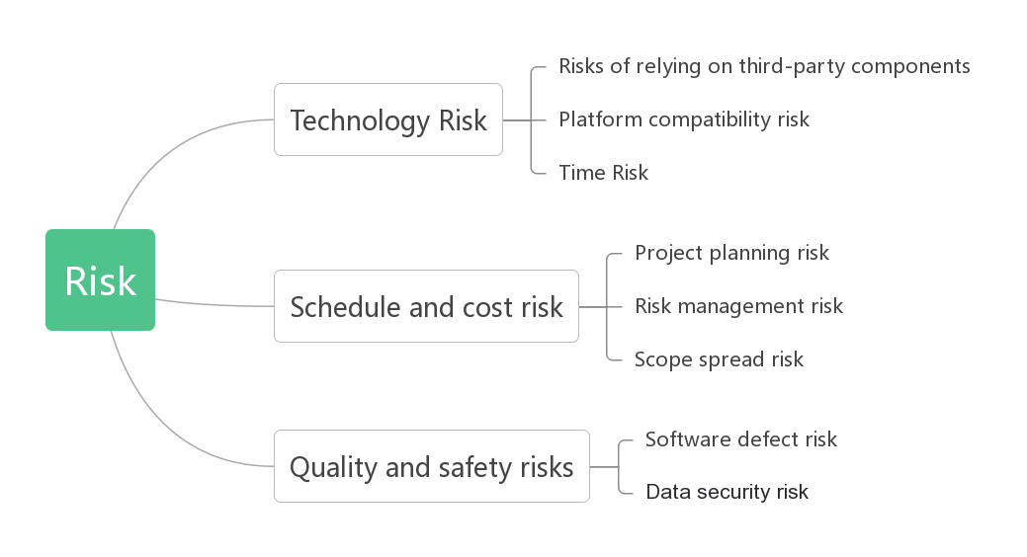

## Risk Evaluation

|  |  |  |  |
| --- | --- | --- | --- |
| Risk | Category | Probability | Impact |
| Risks of relying on third-party components | Technology | 50% | Medium |
| Platform compatibility risk | Technology | 10% | Low |
| Time Risk | Technology | 60% | Medium |
| Project planning risk | Schedule and cost risk | 80% | Medium |
| Risk management risk | Schedule and cost risk | 25% | Medium |
| Scope spread risk | Schedule and cost risk | 15% | High |
| Software defect risk | Quality and safety risks | 1% | Low |
| Data security risk | Quality and safety risks | 10% | High |

|  |  |  |  |  |
| --- | --- | --- | --- | --- |
| **Risk** | **Probability** | **Impact($)** | **Note** | **EMV($)** |
| Platform compatibility risk | 10% | -2000 | Projects may have compatibility issues on different platforms | -300 |
| Time Risk | 60% | -5000 | Need more fund  to run the project | -50 |
| Project planning risk | 8% | 500 | Evaluate the reasonableness, feasibility and controllability of the project plan | 50 |
| Scope spread risk | 5% | -1000 | Consider the likelihood and frequency of requirements changes | -50 |
| Software defect risk | 1% | -500 | Evaluate quality control measures and test coverage during software development | -5 |
| Data security risk | 10% | -2000 | Need to protect our database | -200 |
| Risks of relying on third-party components | 50% | 5000 | Need to get more money from client | 400 |
| Total |  |  |  | -155 |

## Risk Avoidance

Risk events can often be avoided or reduced by making advance changes in preparation. Risk Avoidance entails avoiding potential hazards whenever possible. Efforts can be made to stop using or refuse to use the procedure that creates the risk in order to prevent the risk from occurring, therefore avoiding the risk of loss. The benefits of risk avoidance are simplicity, immediacy, completeness, and thoroughness, and because the source of risk has been eliminated, it may minimize the risk of occurrence and ensure the safe operation of the project. Alternative strategy is another name for risk avoidance. Addressing a specific hazard usually requires Removing the primary cause of the risk. While a project management team cannot eliminate all risks, it can eliminate all risks, it can eliminate the occurrence of certain risks.

In addition, there are generic risk avoidance measures that apply to multiple risk categories:

Conduct regular risk assessments and management, and keep risk registers and risk responses up to date.

Establish effective communication channels to maintain communication and transparency with stakeholders.

## Transfer Risk

Risk transfer is the process of transferring risk liability and losses to other entities or institutions. The following are a few common methods of risk transfer:

1. Insurance:

- Purchase appropriate insurance policies to transfer specific types of risks, such as property damage, liability risk, business interruption, etc.

- Periodically evaluate and review insurance policy coverage and premiums to ensure a match to the risk.

2. Contracts and Agreements:

- When entering into contracts with suppliers, partners or contractors, clearly agree on risk sharing and liability transfer clauses.

- Ensure that contracts contain appropriate risk management and liability clauses for breach of contract.

3. Outsourcing and subcontracting:

- Transfer some of the risk to specialized suppliers or contractors by outsourcing or subcontracting.

- Ensure that contracts are signed with the outsourcer or subcontractor and that appropriate risk sharing and liability provisions are agreed upon.

4. Transfer to the market:

- Transfer risk through the sale or resale of risky assets, such as debt securitization, project sale, etc.

- This applies to certain specific types of risk, such as financial risk or investment risk.

5. Diversification:

- Diversifying investments into different asset classes, industries, or geographic areas to reduce the risk associated with a particular investment.

- By diversifying the portfolio, the impact of a particular risk on the overall portfolio can be reduced.

The nature, impact and cost of risk need to be carefully evaluated before risk transfer is made. Also, ensure that the method of transferring risk meets legal and compliance requirements and that a reliable and reputable partner or institution is selected. Risk transfer is only one part of a risk management strategy; other measures such as risk avoidance, risk mitigation and risk acceptance also need to be considered in an integrated manner.

## Risk Control